**Bunbury Senior High School Name:_____________________________**

Total time allowed: 55 minutes

Test 6 Total Marks _____ / 50 _____%

**Mathematics: Methods Unit 2**

**Test 6, 2018**

**Differentiation and Integration with Applications**

**Section One:**

**Calculator-free**

Time allowed for this section: 20 minutes

Total marks for this section: 18 marks

**Materials required for this section:**

SCSA Formula Sheet

**Instructions to candidates**

Show all your working clearly. Your working should be in sufficient detail to allow your answers to be checked readily and for marks to be awarded for reasoning. Incorrect answers given without supporting reasoning cannot be allocated any marks. For any question or part question worth more than two marks, valid working or justification is required to receive full marks. If you repeat any question, ensure that you cancel the answer you do not wish to have marked.

|  |  |
| --- | --- |
| **Question 1** | **[1, 2 = 3 marks]** |

a) Differentiate the following functions. Express all derivatives with positive powers.

i) $y=-4x^{3}$

ii) $y=\frac{2x^{2}}{5}-\frac{1}{x^{3}}$

|  |  |
| --- | --- |
| **Question 2** | **[3, 3 = 6 marks]** |

a) Determine the equation of the tangent to the curve $y=x^{3}-4x^{2}-3$ at the point (2, -11).

b) Determine the *x*-coordinates of any stationary point(s) of the function $f\left(x\right)=-2x^{3}+6x^{2}+18x$

|  |  |
| --- | --- |
| **Question 3** | **[2 marks]** |

Determine the following integral.

$\int{-12x^{5}+3x^{2} dx}$

|  |  |
| --- | --- |
| **Question 4** | **[2 marks]** |

Given the sketch of $y=f(x)$, sketch a possible graph of $y=f'(x)$ on the axis below.

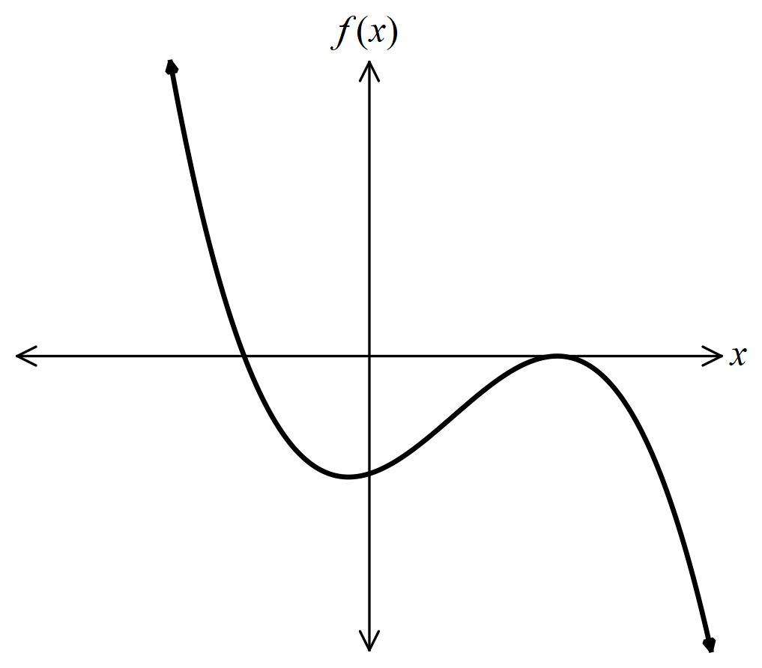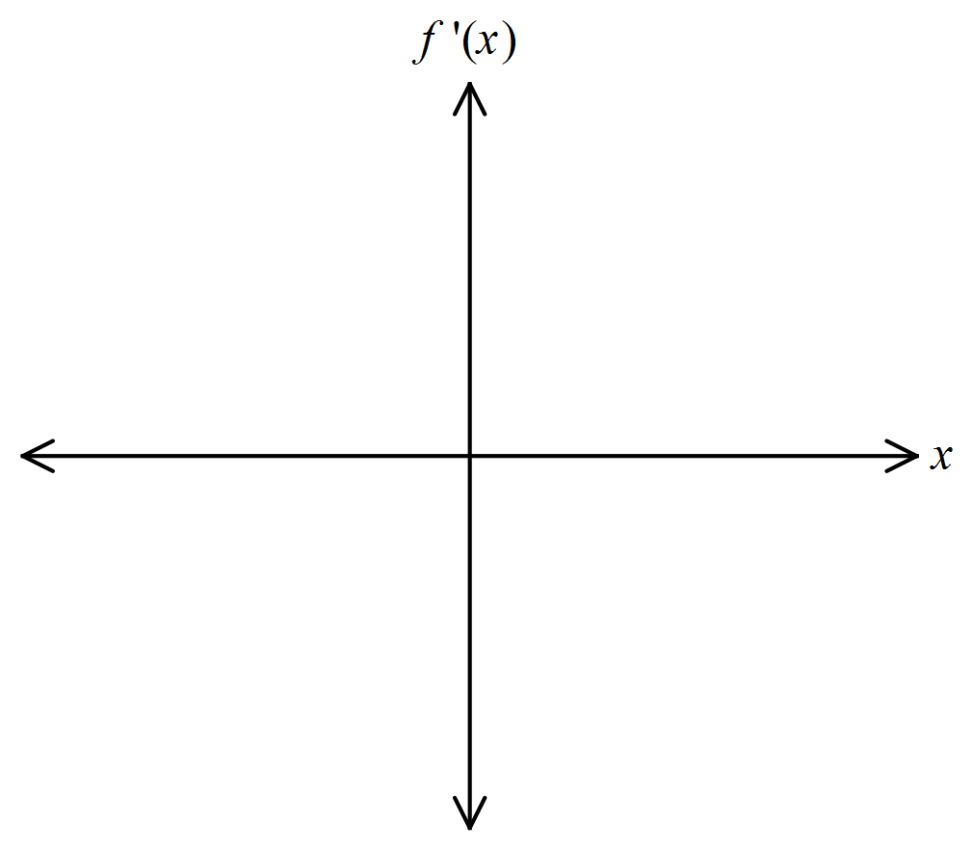

|  |  |
| --- | --- |
| **Question 5** | **[1, 2, 1, 1 = 5 marks]** |

The accompanying diagram shows the displacement (metres) time graph of an object P moving in a straight line from a fixed point O for $0≤t≤10$ seconds.

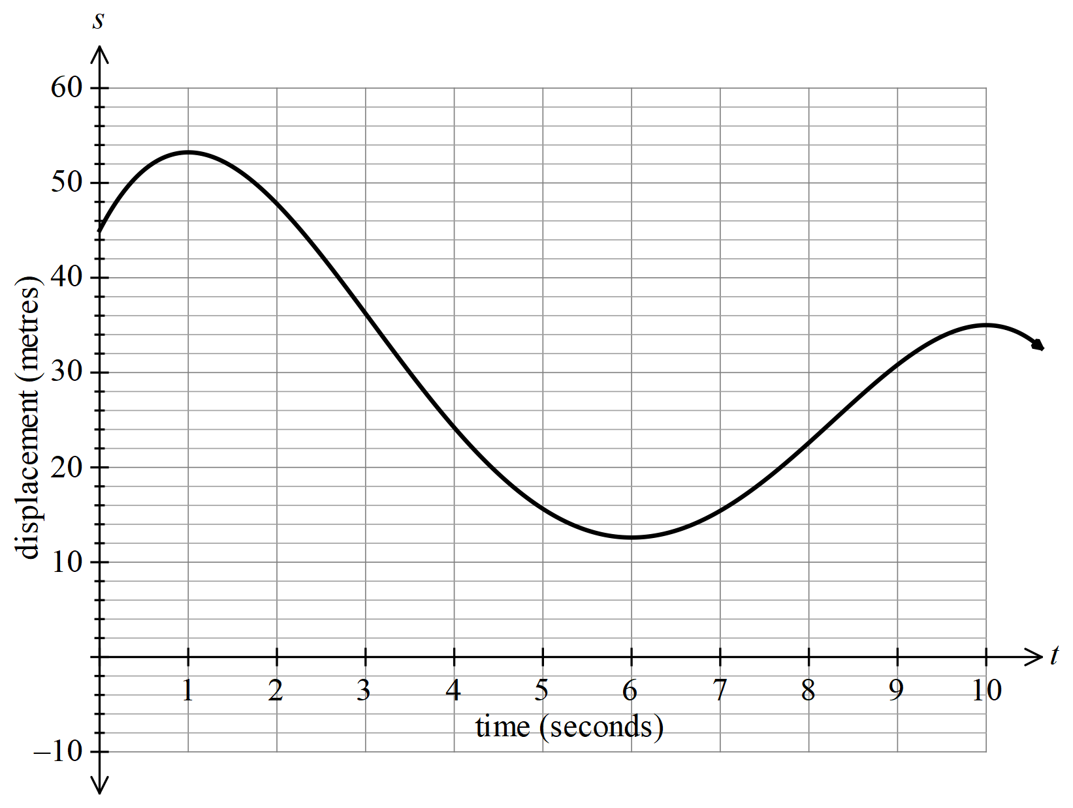

Use this diagram to estimate:

a) the initial displacement of P

b) when the object P is at rest

c) the velocity of P at $t=7$ seconds

d) when the velocity of P is -12 m/s.

**Bunbury Senior High School Name:____________________________**

**Mathematics: Methods Unit 2**

**Test 6, 2018**

**Differentiation and Integration with Applications**

**Section Two:**

**Calculator-assumed**

Time allowed for this section: 35 minutes

Total marks for this section: 32 marks

**Materials required/recommended for this section:**

SCSA Formula Sheet

Notes on one sheet (both sides) of A4 paper

Up to three approved calculators

**Instructions to candidates**

Show all your working clearly. Your working should be in sufficient detail to allow your answers to be checked readily and for marks to be awarded for reasoning. Incorrect answers given without supporting reasoning cannot be allocated any marks. For any question or part question worth more than two marks, valid working or justification is required to receive full marks. If you repeat any question, ensure that you cancel the answer you do not wish to have marked.

|  |  |
| --- | --- |
| **Question 6** | **[4 marks]** |

Find the derivative of $y=3x^{2}$ from first principles.

|  |  |
| --- | --- |
| **Question 7** | **[3 marks]** |

The curve $y=x^{2}-a\sqrt{x}$ has a stationary point at $x=4$. Find the value of $a$.

|  |  |
| --- | --- |
| **Question 8** | **[6 marks]** |

Use derivatives to find the stationary points(s), for the curve, $y=\frac{1}{10}x^{5}+2x^{2}$. Hence, sketch the curve, clearly indicating all stationary point(s) and intercept(s).

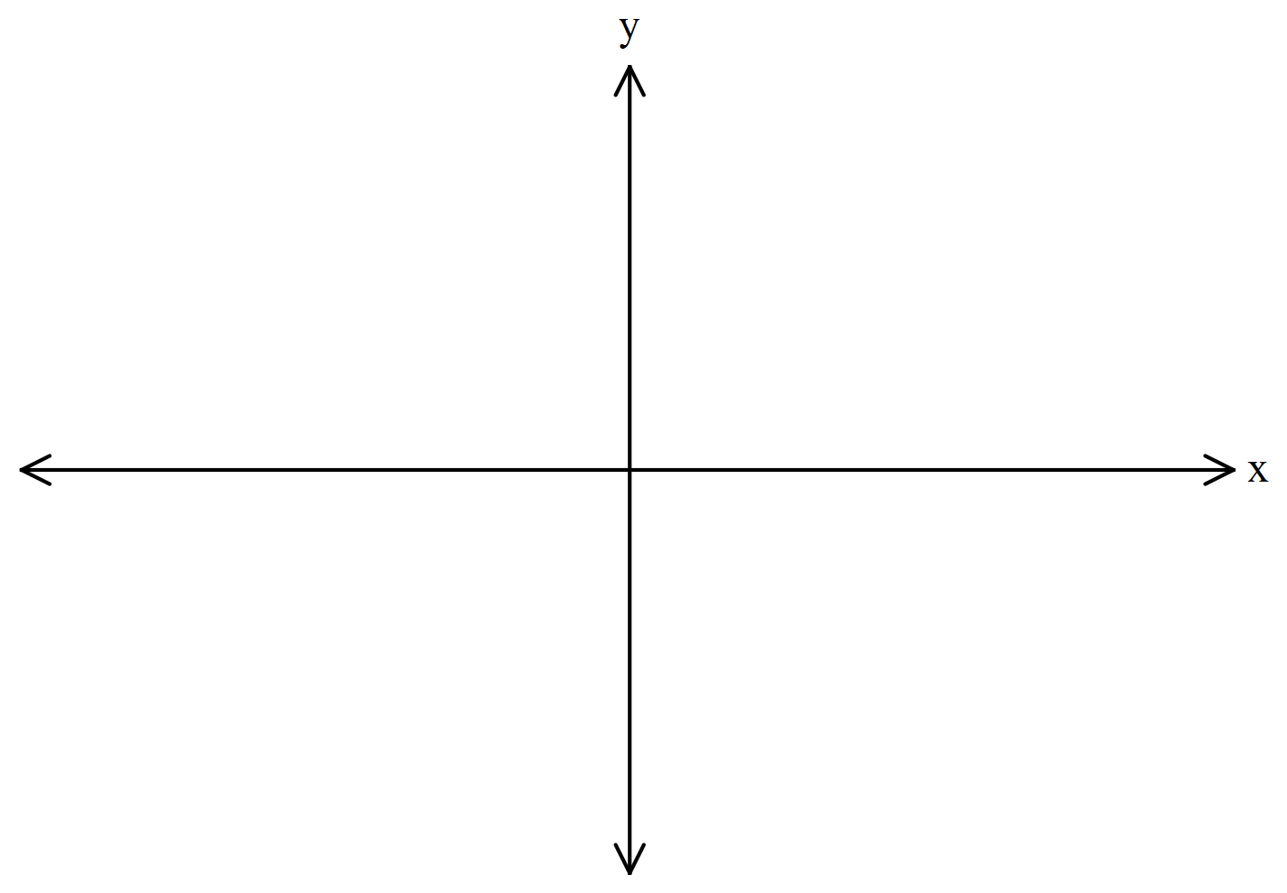

|  |  |
| --- | --- |
| **Question 9** | **[1, 2, 2 = 5 marks]** |

A car is travelling in a straight line. The car’s distance $s$ metres, from a fixed point O, is given by,

$s=10+14t+\frac{1}{3}t^{3}$ for $t≥0$, where time $t$ is in seconds.

a) Find the initial velocity of the car.

b) Find when the velocity of the car is 18 ms-1.

c) Find the average speed of the car in the first 4 seconds.

|  |  |
| --- | --- |
| **Question 10** | **[1, 1, 2, 2 = 6 marks]** |

A crack in an oil pipe on the ocean floor leaks oil to the surface. The total area of oil contamination on the ocean’s surface, in square kilometres (km2), is modelled by the function, $A=0.05(3t^{3}-55t^{2}+248t)$, where $t$ is the number of days since the pipe started to leak oil.

a) Find an expression for the rate of change in $A$ with respect to $t$.

b) Find the rate of change in $A$ with respect to $t$ after 1 day of the oil starting to leak into the ocean.

The oil company that owns the pipe are quick to respond to the broken pipe and start to repair the pipe and clean the ocean surface of oil contamination.

c) After how many day is the spread of oil on the ocean surface stopped?

d) Find the rate of change in $A$ with respect to $t$ after 6 days of the oil starting to leak into the ocean. Briefly

comment on the meaning of this result.

|  |  |
| --- | --- |
| **Question 11** | **[1, 3, 4 = 8 marks]** |

A rectangular sheet of cardboard, 40 cm by 60 cm, is to be made into a closed rectangular box. A square of side,

$x$ cm, is removed from each of the corners A and B of the cardboard. A rectangle $x$ cm by $y$ cm, is removed from each of the corners C and D of the cardboard.

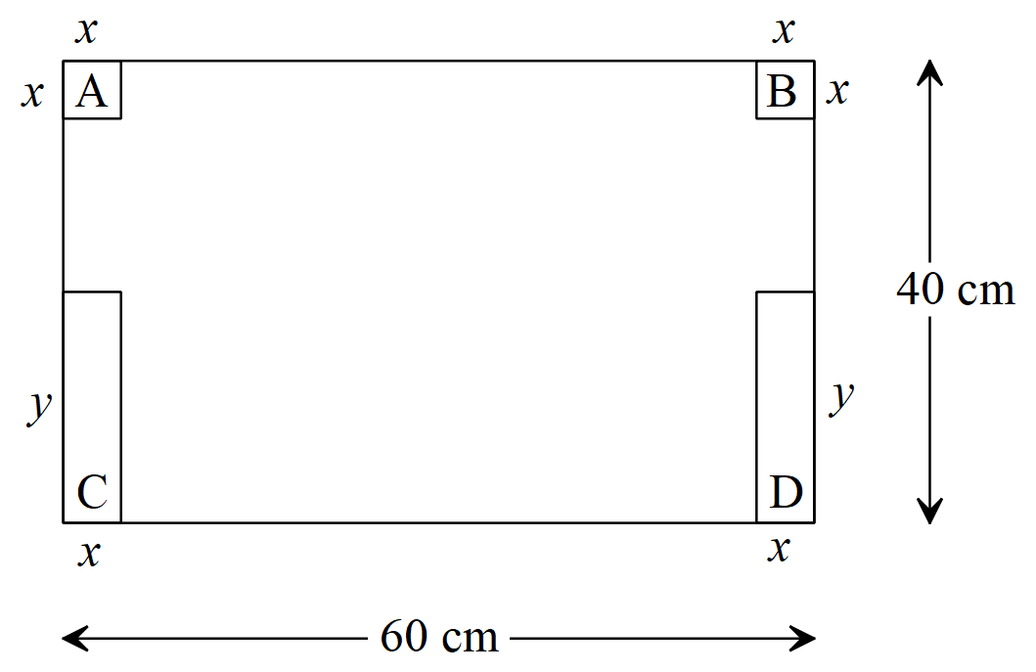

a) Show that the length of the box is given by $L=60-2x$.

b) Show that the volume, $V$, of the box is given by

$V=x(60-2x)(20-x)$

c) Use calculus to find the dimensions of the box that will maximise its volume, all correct to 2 decimal places.